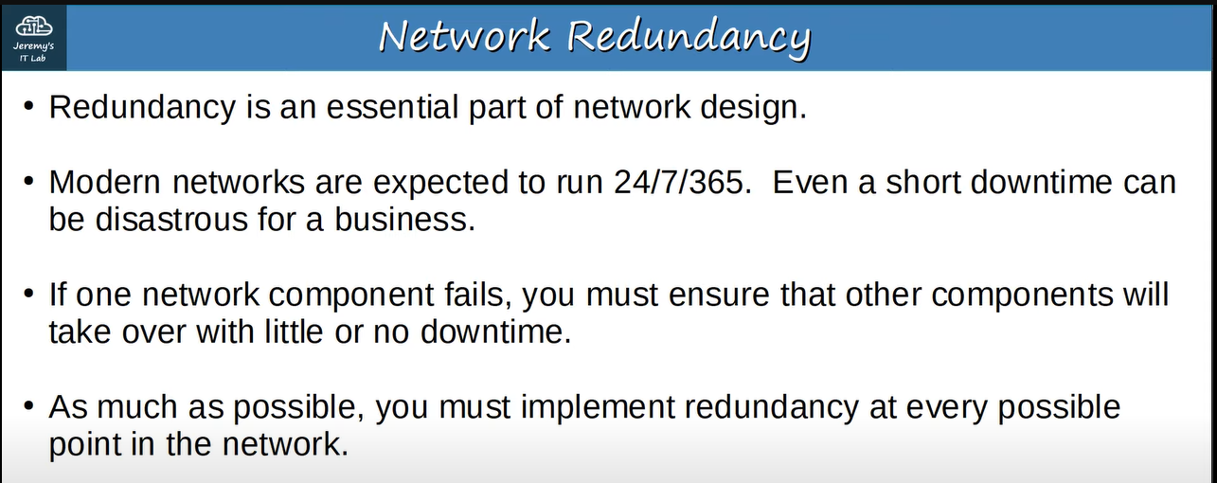**E.g., ↓**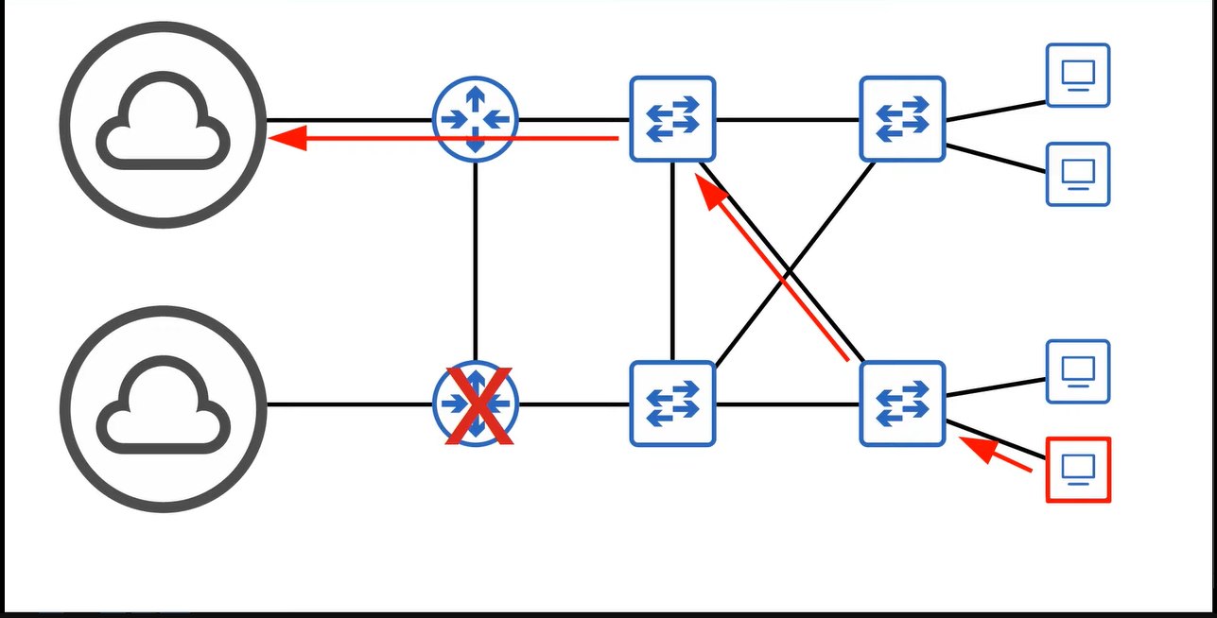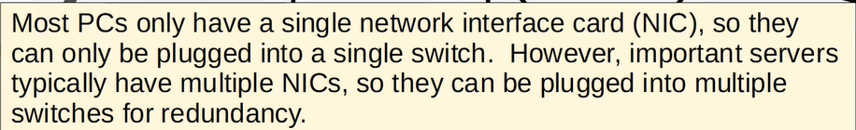

**Now we will see that what is the broadcast storm? ↓**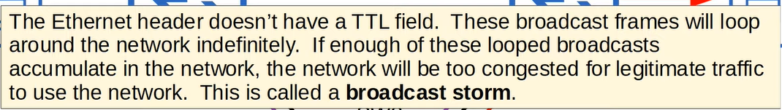

**E.g., ↓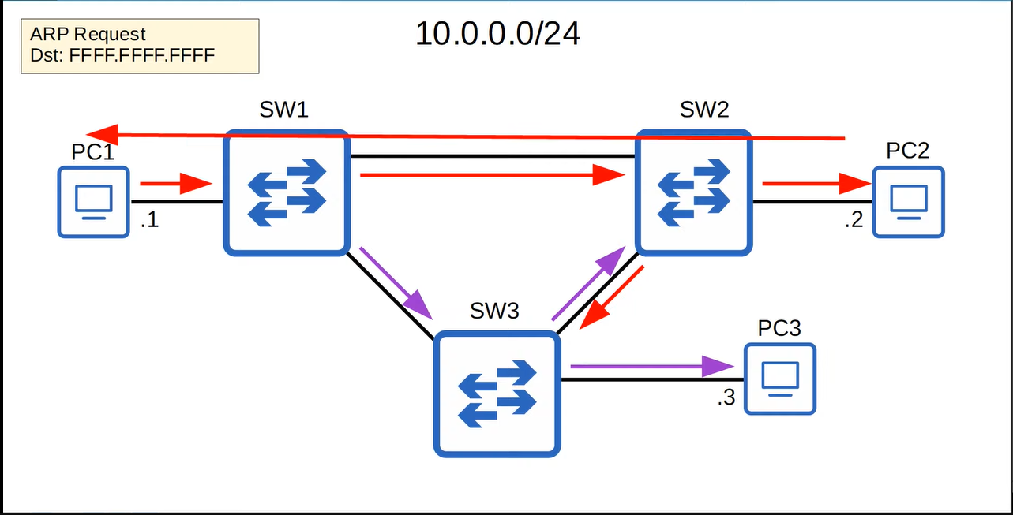 ↓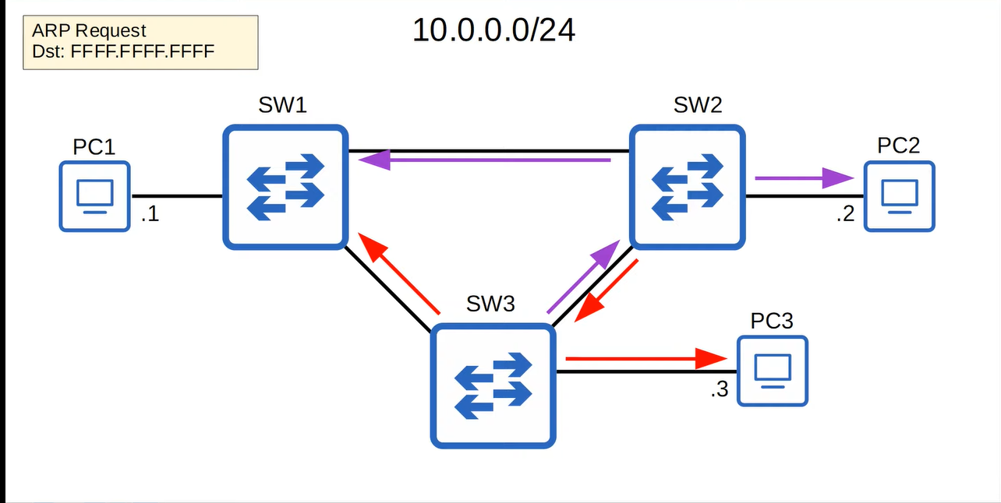 ↓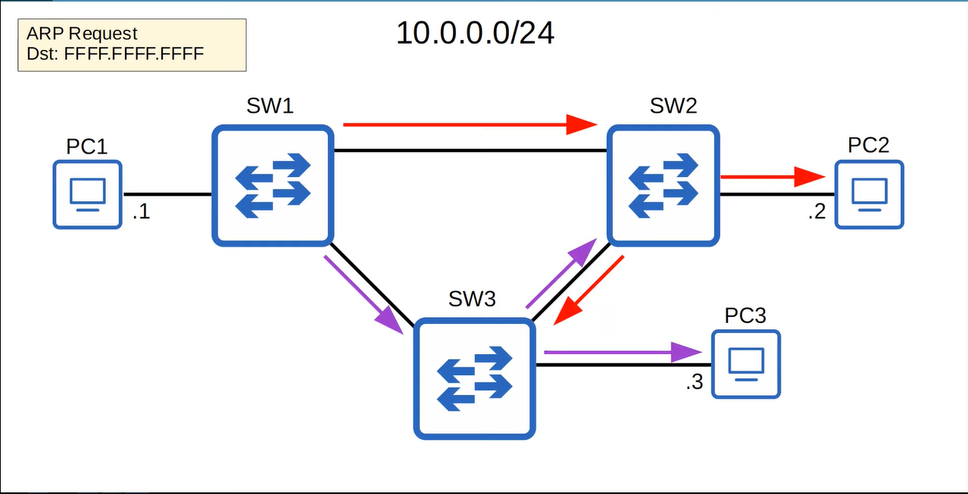 ↓**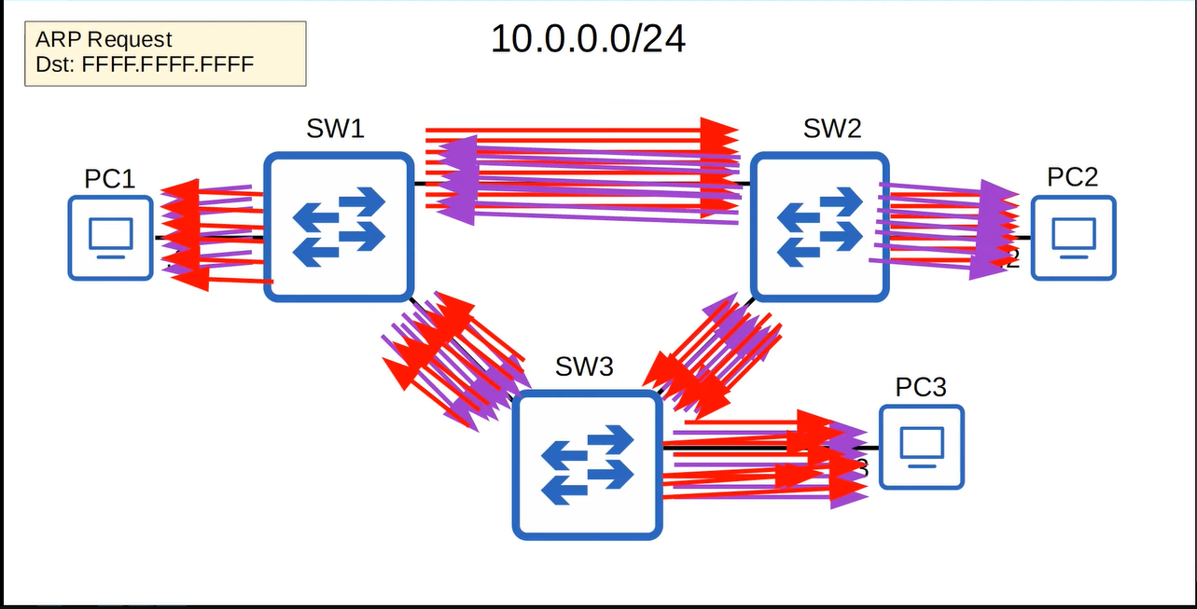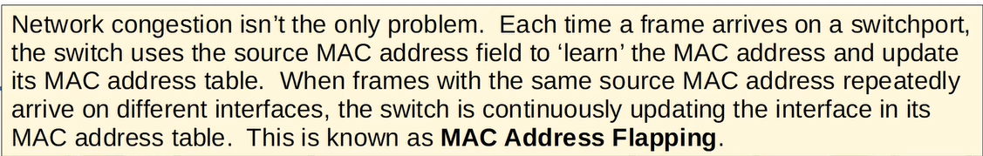

**STP is one answer to these problems**

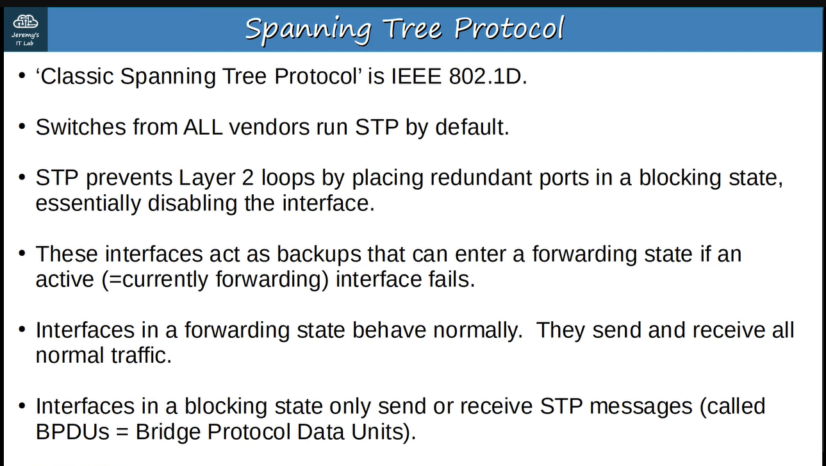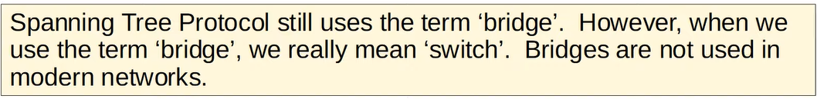**let’s understand the purpose of STP ↓**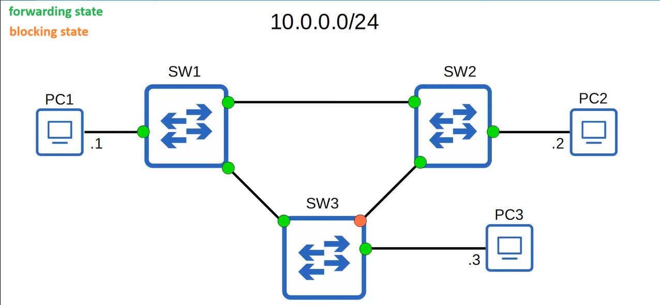

**That port is in blocking state to prevent the “broadcast storm”. Suppose, due to some reason, the interface od SW2 that is connecting it to SW1 is disabled then that interface of SW3 becomes in forwarding mode ↓**

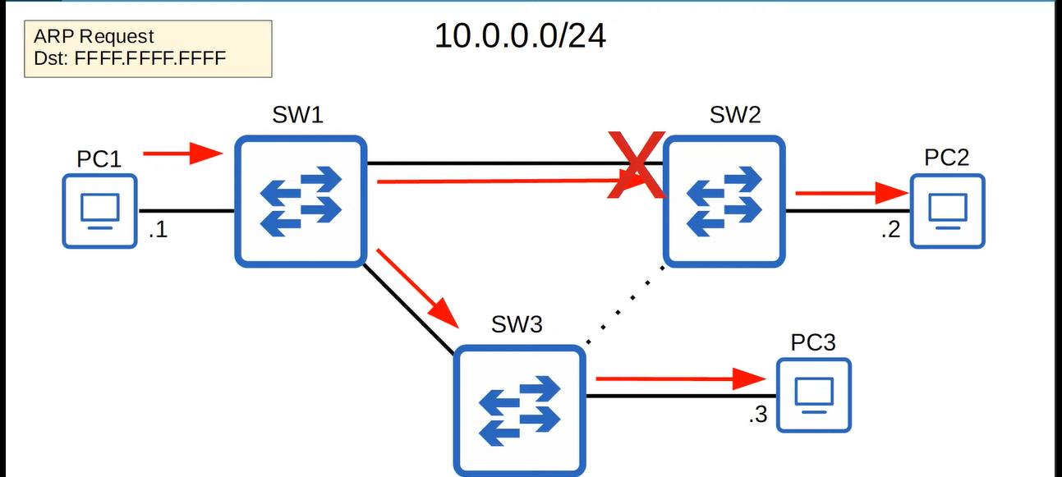 **↓**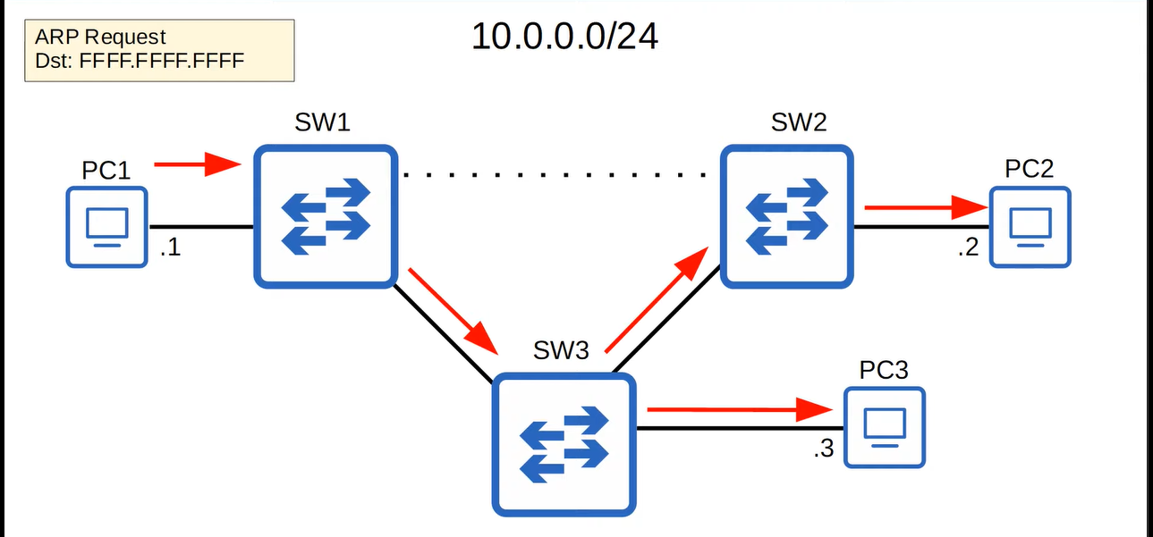

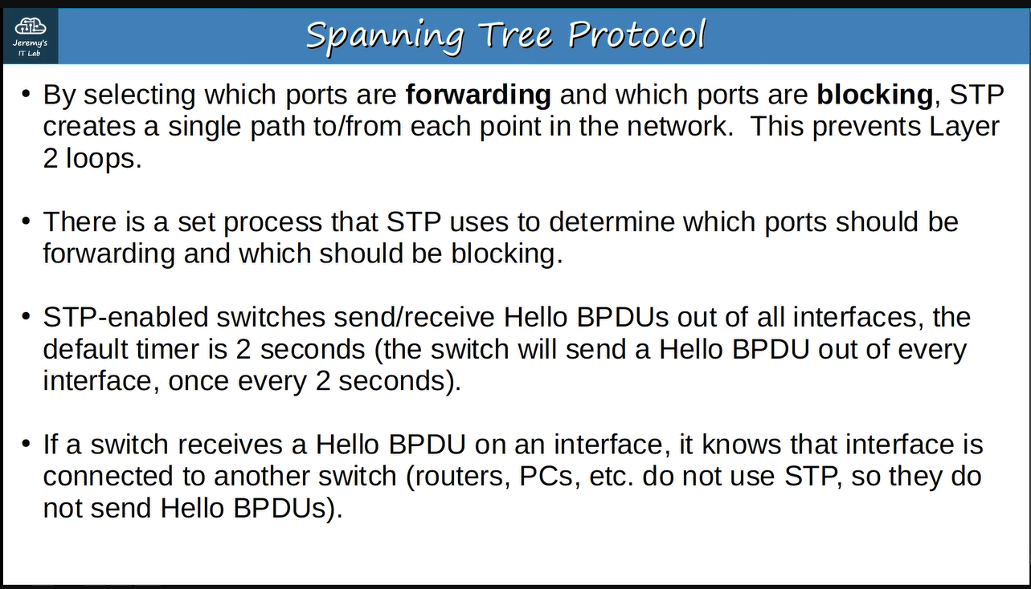

**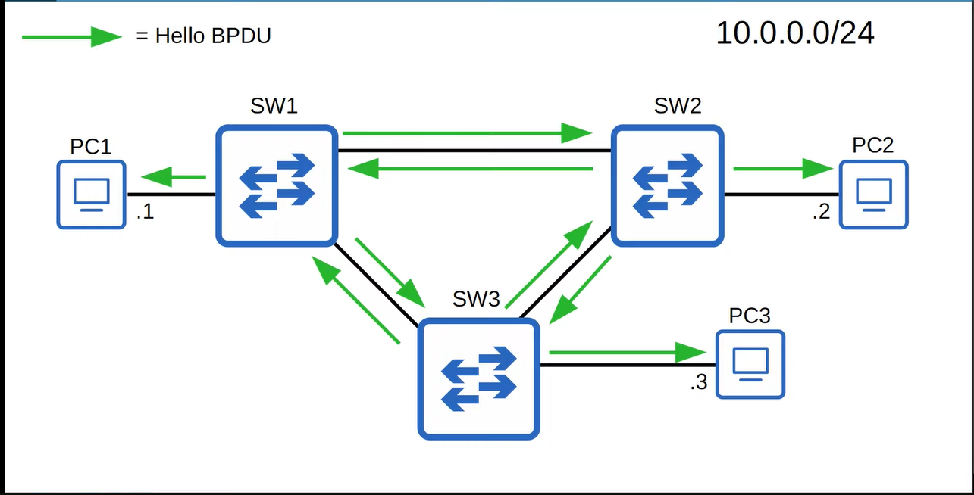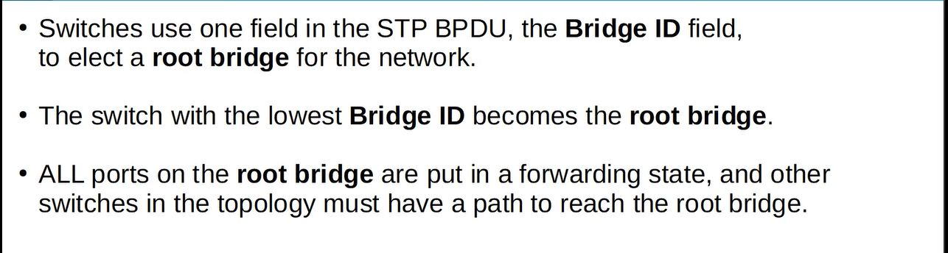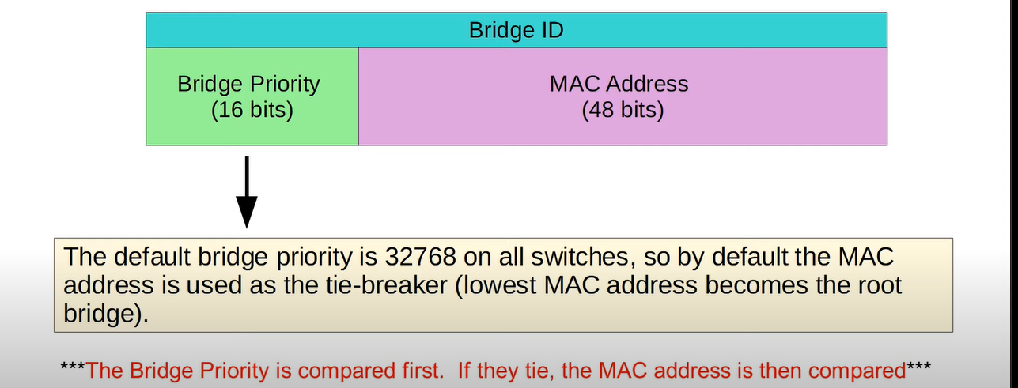  
e.g., ↓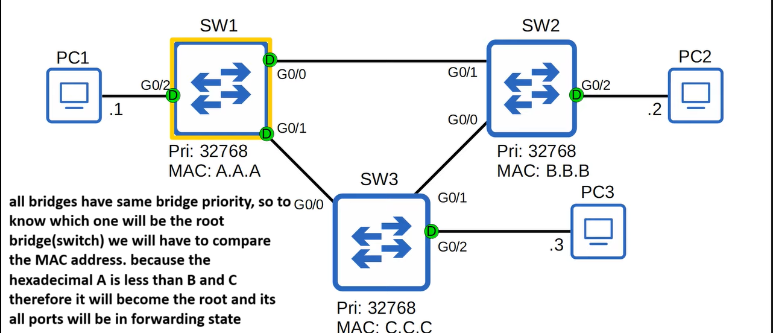Now the “Bridge Priority” has been updated ↓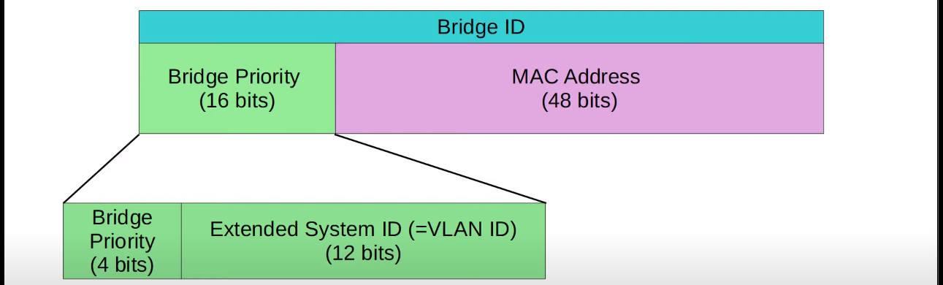Why VLAN ID has been added ↓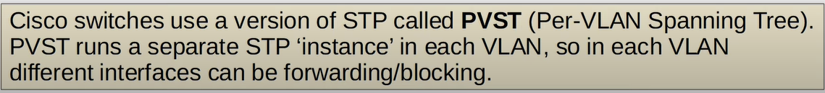by adding the VLAN ID into bridge priority, the switch will have the different bridge id in each VLAN, so in each VLAN different interfaces can be forwarding or blocking, e.g., one interface could be forwarding in VLAN1 but blocking in VLAN2**

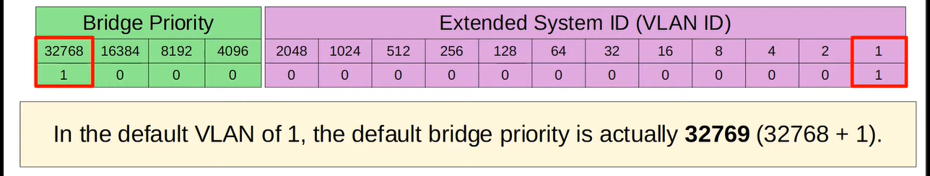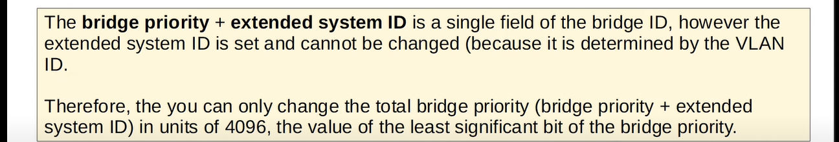

**E.g., ↓ 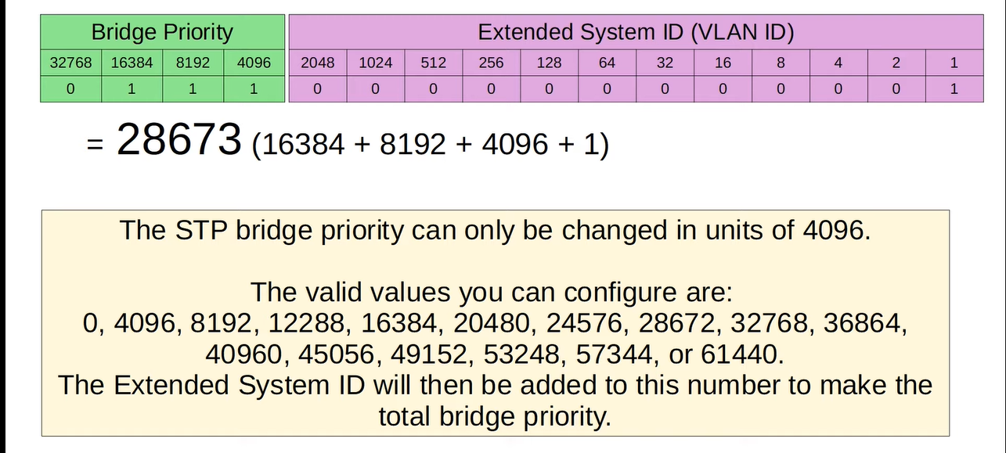Remember ↓**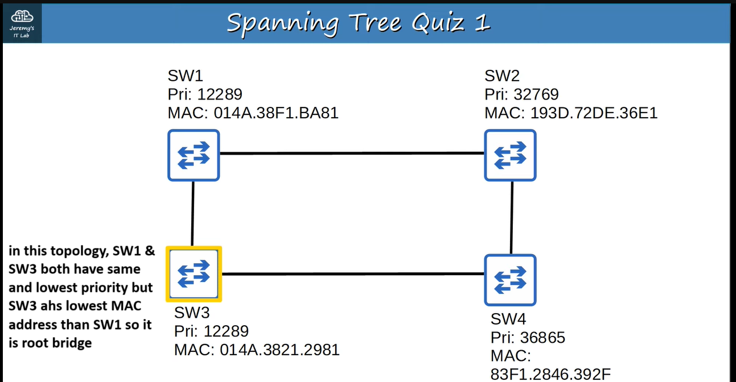

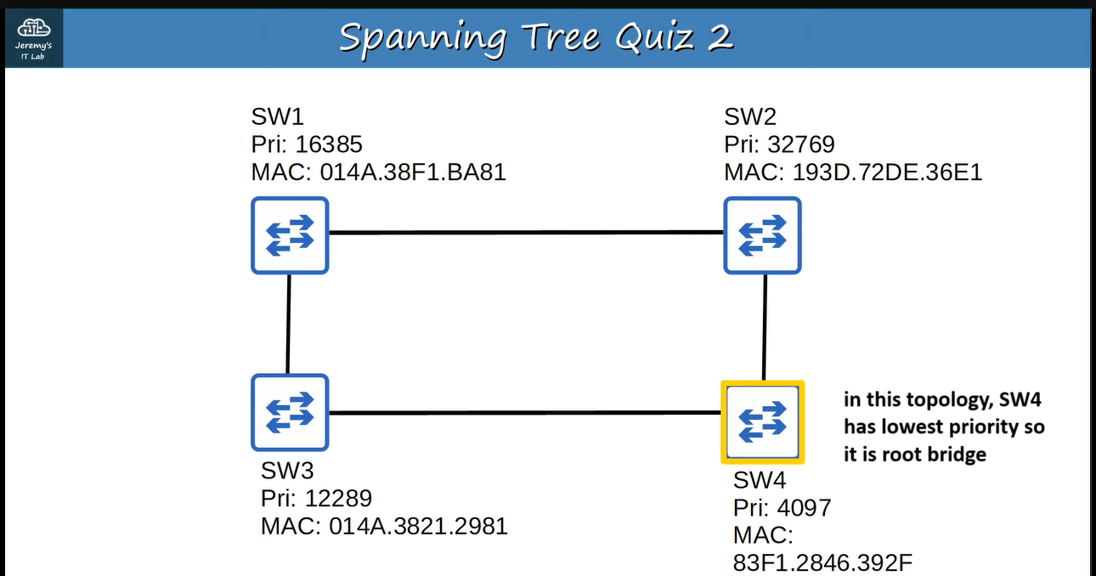

**What is the root cost? ↓**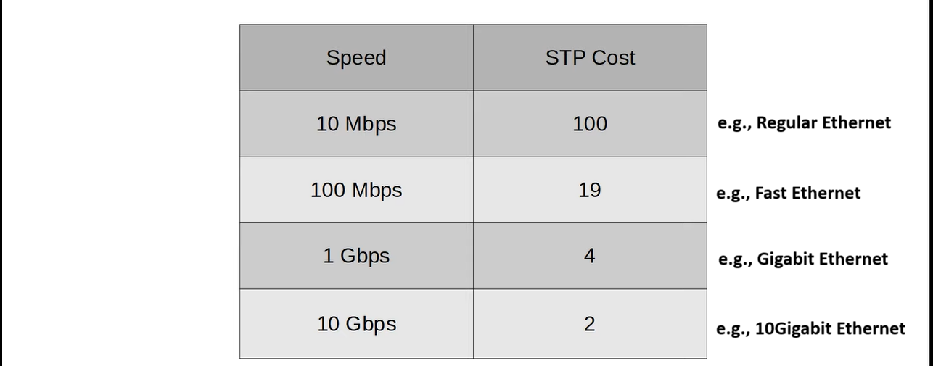

**Let’s understand it with an example but remember the interface with the lowest root cost will be the root port ↓**

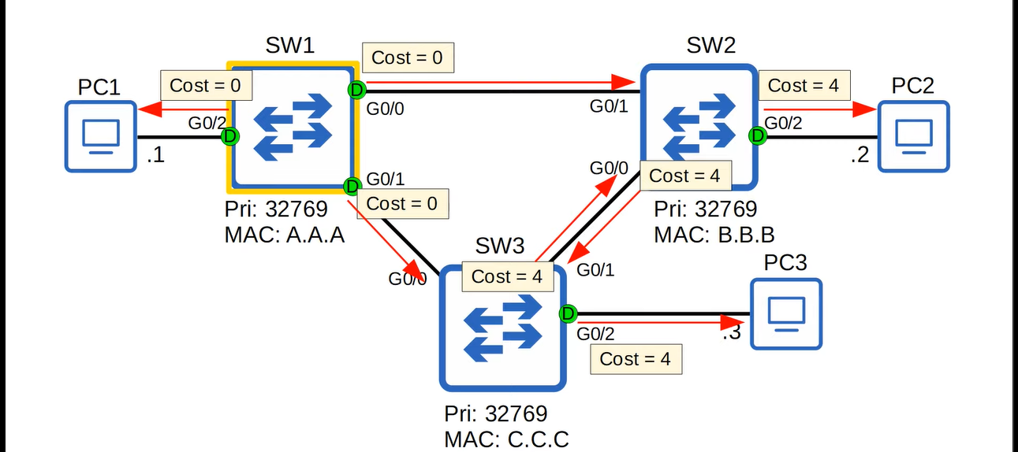**G0/1 of SW2 has lowest root cost and similarly G0/0 of SW3 has the lowest root cost, so they will become root ports of their respective switches ↓**

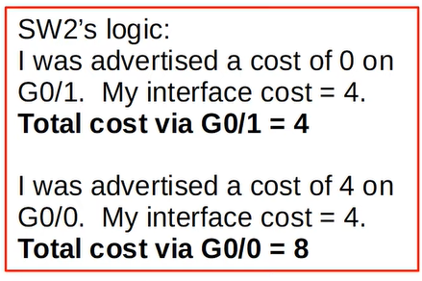 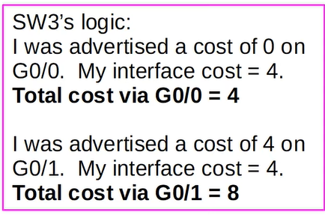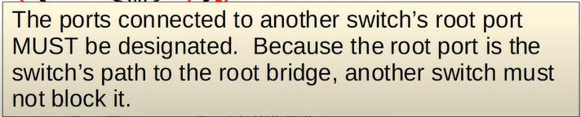

**e.g., G0/0 & G0/1 must be designated. So the summary is ↓**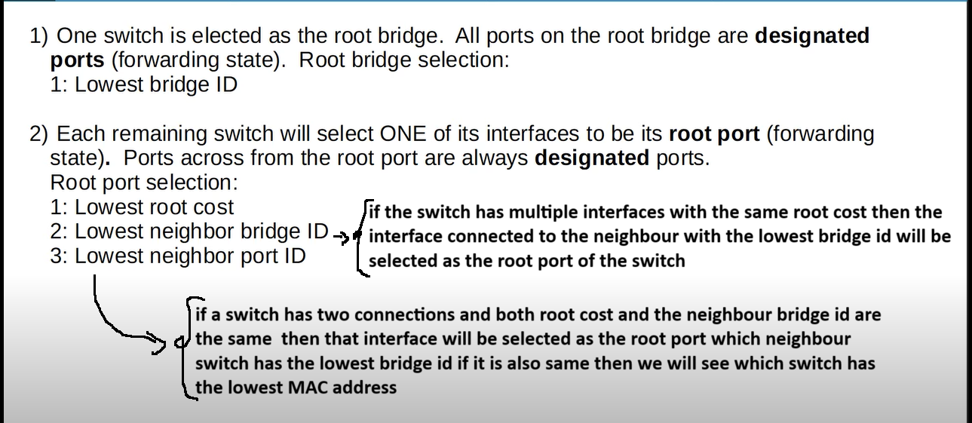

**e.g., ↓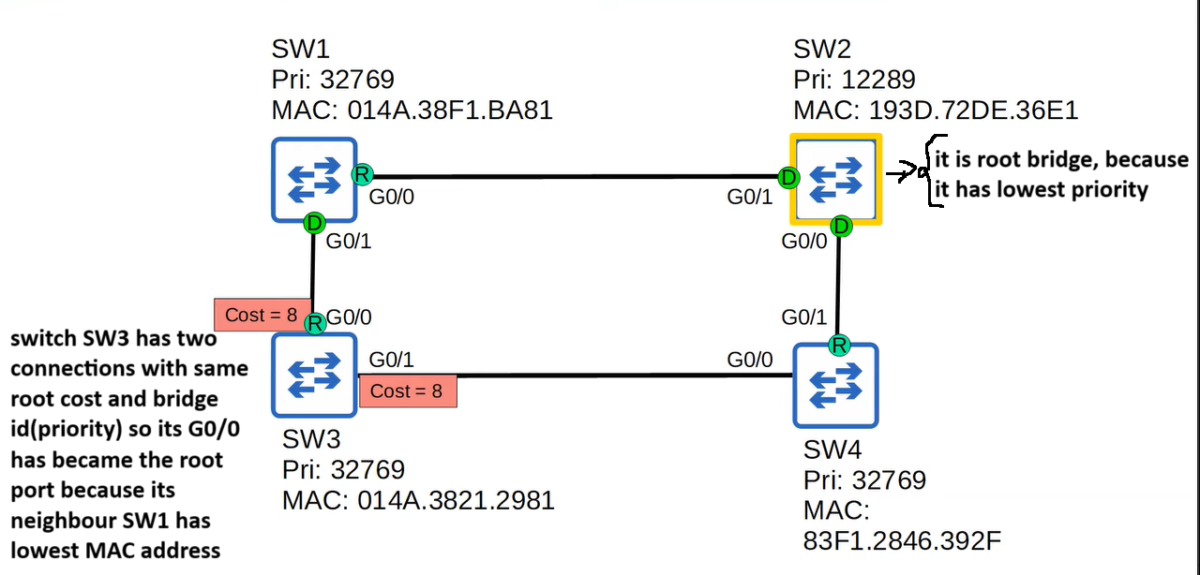Suppose there are two connections between SW1 & SW3 then that interface of SW3 will become the root port which port of SW1 has lowest “port id” and remember ↓**

**Now we will see how is an interface blocked to prevent layer-2 loops ↓**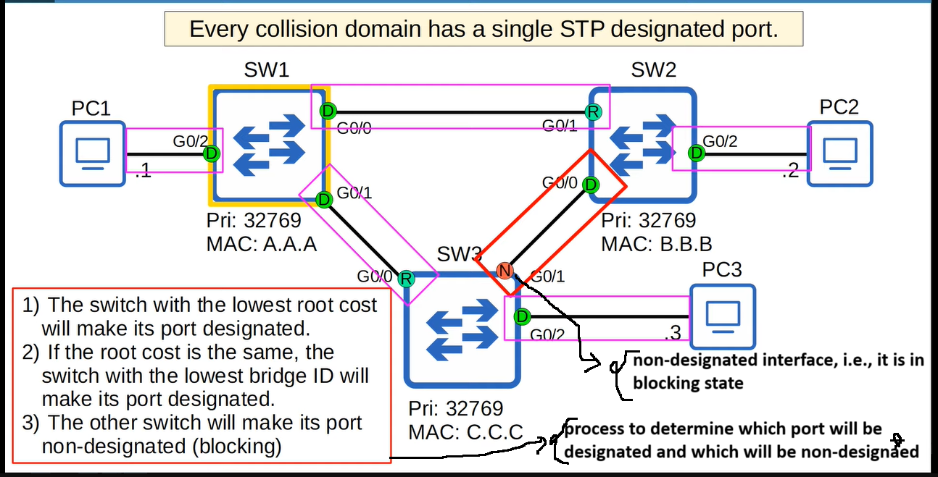

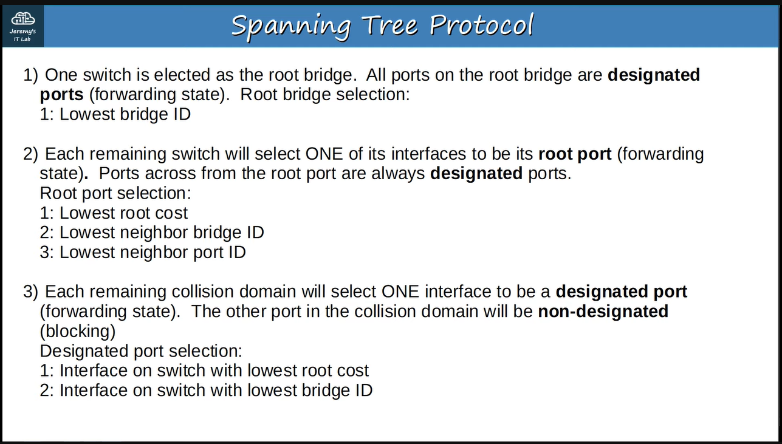

**Other examples ↓**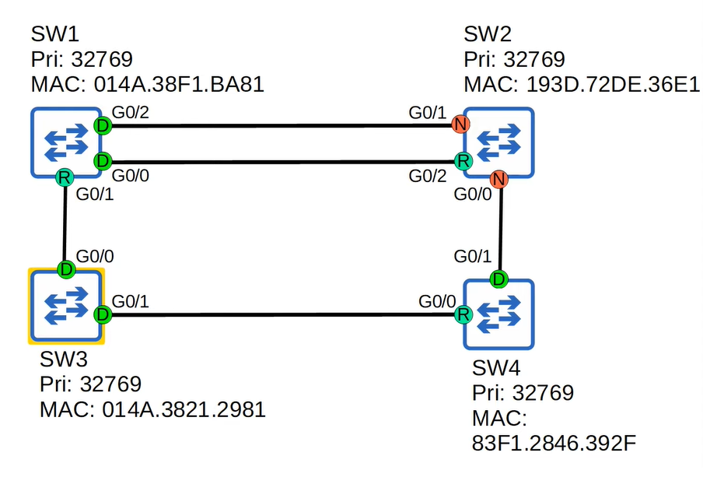

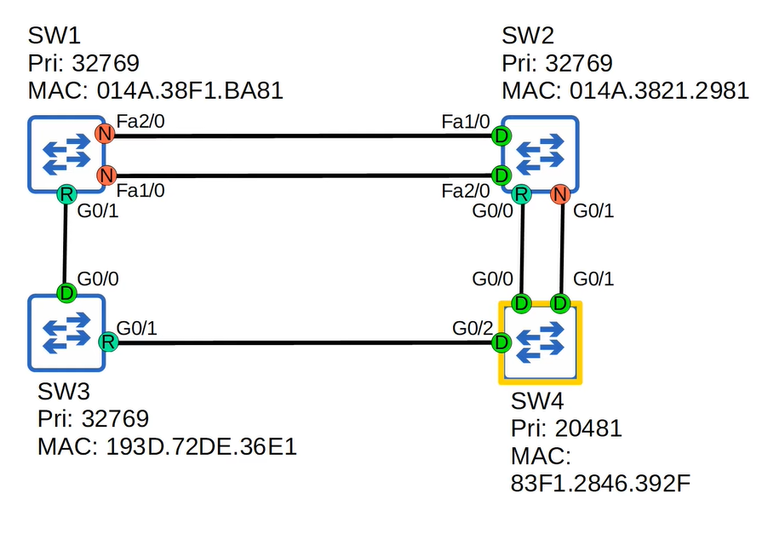

**Command 🡪** SW3#show spanning-tree

using this command we can see the priority and etc. of the switch.